**A.1 Aim: To implement**

1. Design of static website with HTML5 and CSS tags

**A.2 Prerequisite:**

HTML

**A.3 Outcome:**

After successful completion of this experiment students will be able to

1. Understand and implement new HTML 5 tags and make web pages look better by adding CSS.

**A.4 Theory:**

* CSS is a language that describes the style of a HTML document.
* CSS describes how HTML elements should be displayed.
* CSS stands for Cascading Style Sheets
* CSS syntax

Selector , declaration

Ex: h1 Selector

{

font-size:12 Declaration

}

* 3 Types of CSS
  + Inline Style
    - CSS code written with the tag we want to apply style with
    - <h1 style="color:blue;margin-left:30px;">This is a heading</h1>
  + Internal Style
    - CSS code written in the head part of the html
    - <head>  
      <style>  
      body {  
          background-color: linen;  
      }  
        
      h1 {  
          color: maroon;  
          margin-left: 40px;  
      }   
      </style>  
      </head>
  + External Style
    - Css code written in external file and file name included in html head
    - <head>  
      <link rel="stylesheet" type="text/css" href="mystyle.css">  
      </head>

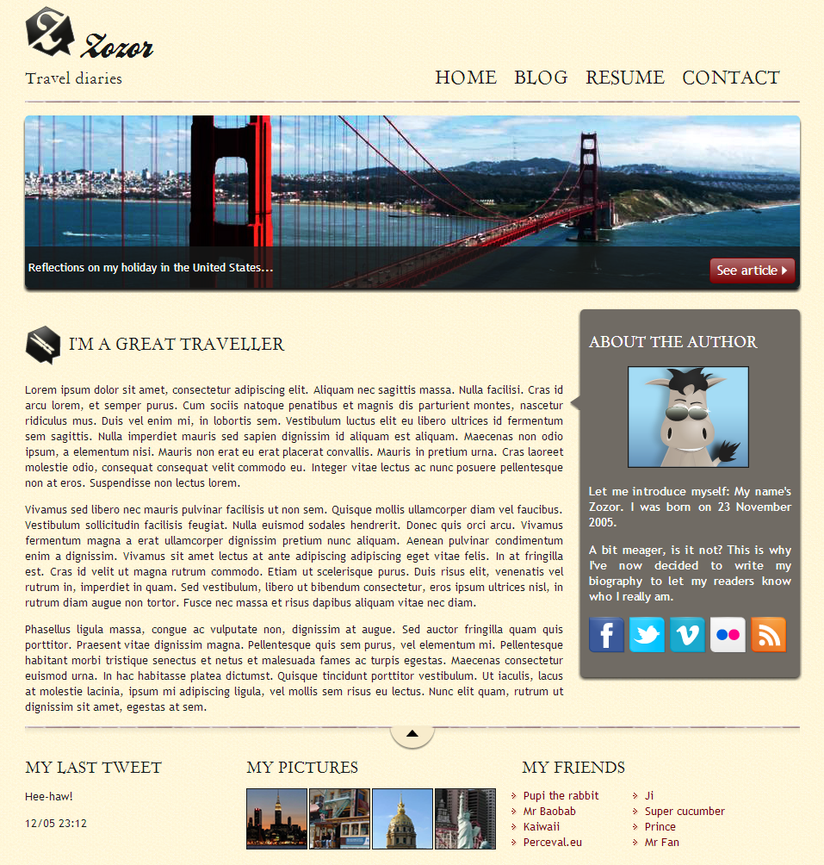

**Note: It is left to discretion of students to decide the topic to make website on. Also students are given freedom to learn more tags and implement it much better to improve UI of the web page.**

**PART B**

**(PART B: TO BE COMPLETED BY STUDENTS)**

**(Students must submit the soft copy as per following segments within two hours of the**

**practical. The soft copy must be uploaded on the Blackboard or emailed to the concerned**

**lab in charge faculties at the end of the practical in case the there is no Black board access**

**available)**

**B.1 Software Code written by student:**

**(Students must paste the code here)**

**B.2 Input and Output**

**(Students must paste input and output here)**

**B.3. Observations and Learning**

**(Students are expected to comment on the output obtained with clear observations and learning for each task/ sub part assigned**

**B.4. Conclusion**

**(Students must write the conclusion as per the attainment of individual outcome listed above and learning/observation noted in Sec. B.3)**

Naman garg B032

Btech CS B

Batch B2

CSS:

.ourlogo {

  border: 10;

}

body {

  background-image: url("bg.jpg");

  background-size: auto;

  background-repeat: repeat;

  background-position: 50% 50%;

}

aside {

  float: right;

  background-color: lightgray;

}

table,

th,

td {

  border: 2px solid black;

  padding: 0;

  border-width: 5px;

  border-collapse: collapse;

  text-align: center;

}

tr:hover {

  background-color: rgb(169, 214, 80);

  transition-delay: 1s;

}

.logos {

  width: 140px;

  height: 140px;

  border: auto;

  margin: auto;

}

figcaption {

  text-align: center;

}

.center {

  text-align: center;

  font-family: monospace;

}

.content {

  font-family: monospace;

  margin: 2%;

  padding: 0;

}

nav {

  text-align: right;

  background: lightgrey;

}

ul#menu li {

  display: inline;

}

figure {

  border-radius: 5;

}

.foot {

  display: inline;

}

.l1 {

  display: inline;

  padding: 10;

}

.text {

  font-size: medium;

  font-family: Arial, Helvetica, sans-serif;

  font-weight: 500;

  color: darkslategrey;

}

footer {

  font-style: oblique;

  text-align: center;

  word-spacing: 5px;

  letter-spacing: 1px;

}

.container {

  position: relative;

  text-align: center;

  color: white;

}

.bottom-left {

  position: absolute;

  bottom: 8px;

  left: 16px;

  font-family: "Courier New", Courier, monospace;

  font-weight: 700;

}

.bottom-left:hover {

  font-size: larger;

}

SS:

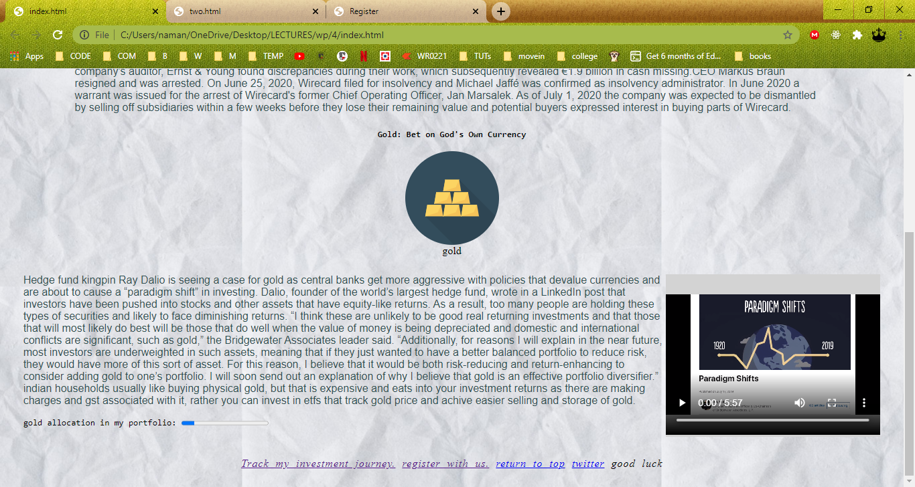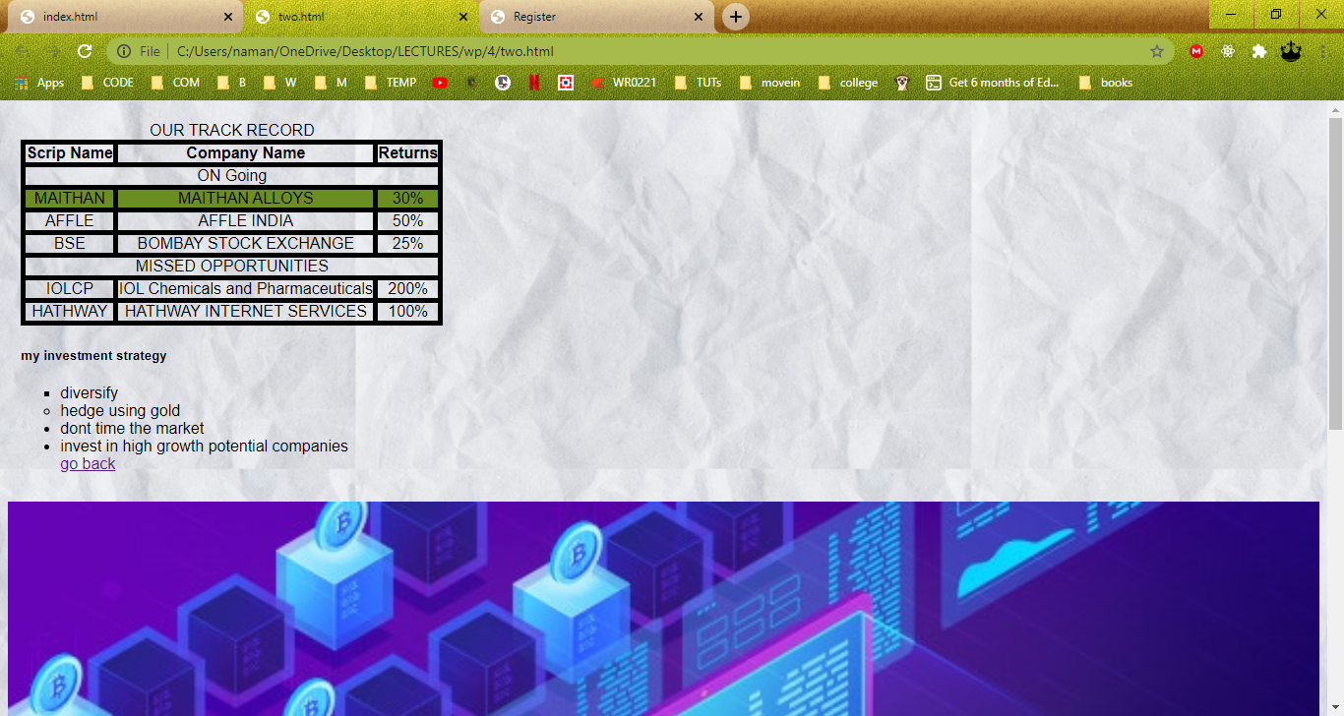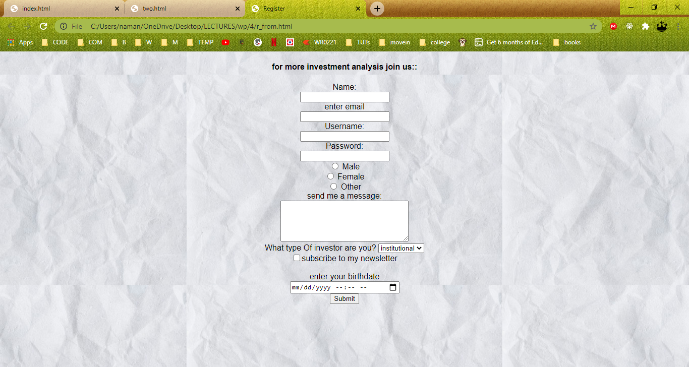

OBSERVATION:

CSS is very convenient to keep the styling out to of the actual content of a website and thus makes our jobs easier

Conclusion:

Designed a static website with HTML5 and CSS tags